**Task No. 1:** Get Order id, Product id, Unit price from Order Details.

**Solution:** select OrderID,ProductID,UnitPrice from [Order Details]

**Output:**

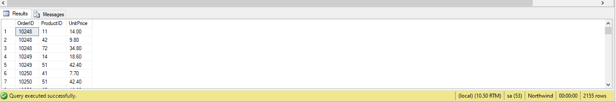

**Task No. 2:** Find Title of employee Nancy.

**Solution:** select Title from Employees where FirstName='nancy'

**Output:**

**Task No. 3:** Display data of all employees those working as Sales Representative from London

**Solution:** select * from Employees where City='London'and Title='sales representative'

**Output:**

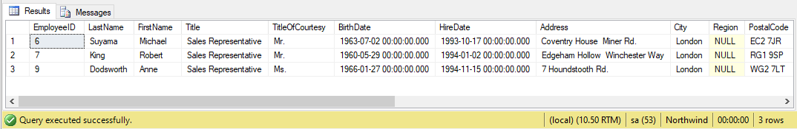

**Task No. 4:** Display product name whose unit price are greater than 90$

**Solution:** select ProductName from Products where UnitPrice>90

**Output:**

**Task No. 5:** Write a query to get current Product list (Product ID and name).

**Solution:** select ProductID,ProductName from Products where Discontinued=0

**Output:**

**Task No. 6:** Fetch data of customers where country is "Germany" AND city must be "Berlin" OR "München" (use parenthesis to form complex expressions)

**Solution:** select * from Customers where Country='germany ' and (City='berlin' or City='München')

**Output:**

**Task No. 7:** Fetch data of customers from all countries except Germany and USA

**Solution:** select * from Customers where Country<>'germany' and Country<>'usa'

**Output:**

**Task No. 8:** Fetch Discontinued products who’s price is greater than 20

**Solution:** select * from Products where UnitPrice>20 and Discontinued=1

**Output:**

